Lab 2
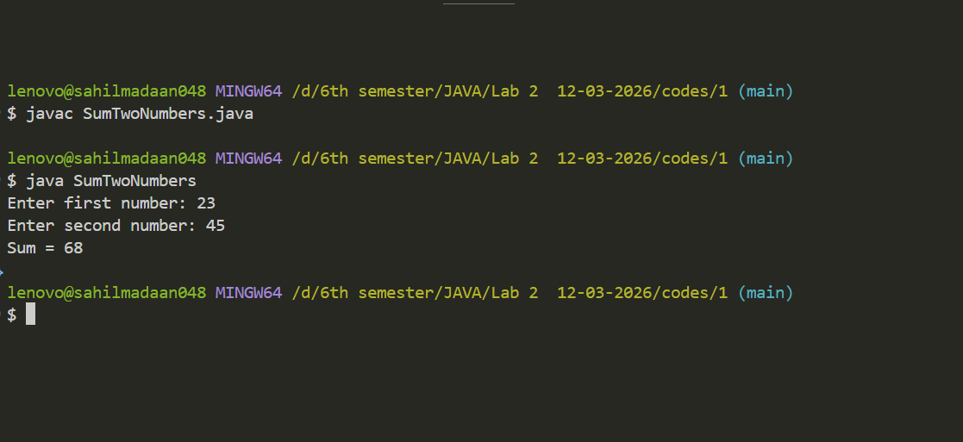
- WAP using functions (methods) to find the sum of two numbers.

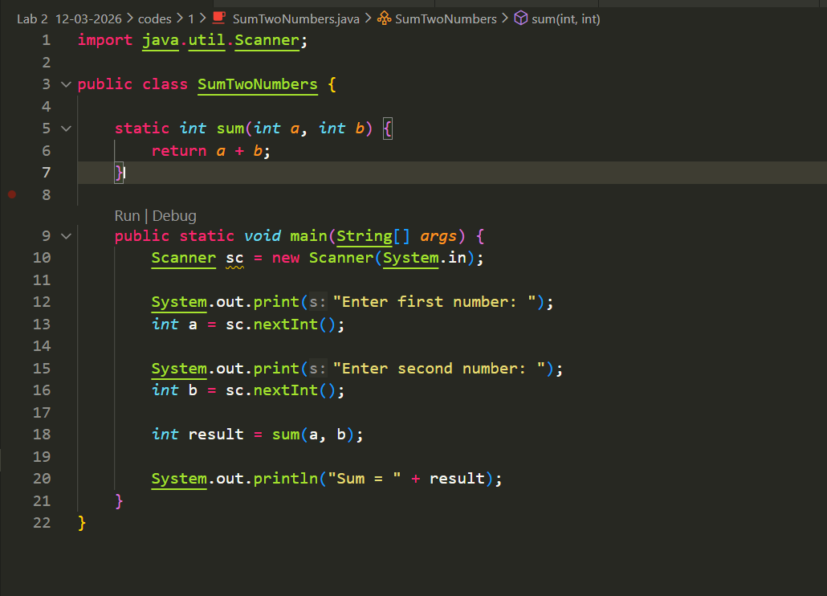

Lab 2
- WAP to calculate the remainder of dividing two numbers and
print the output as "42 divided by 2 gives remainder 0".
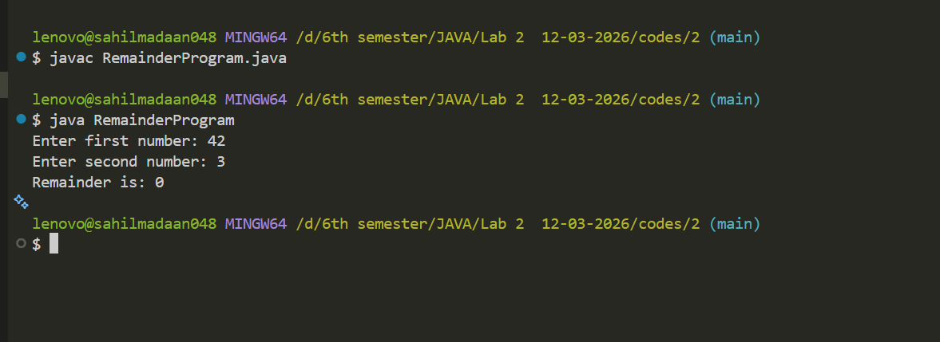

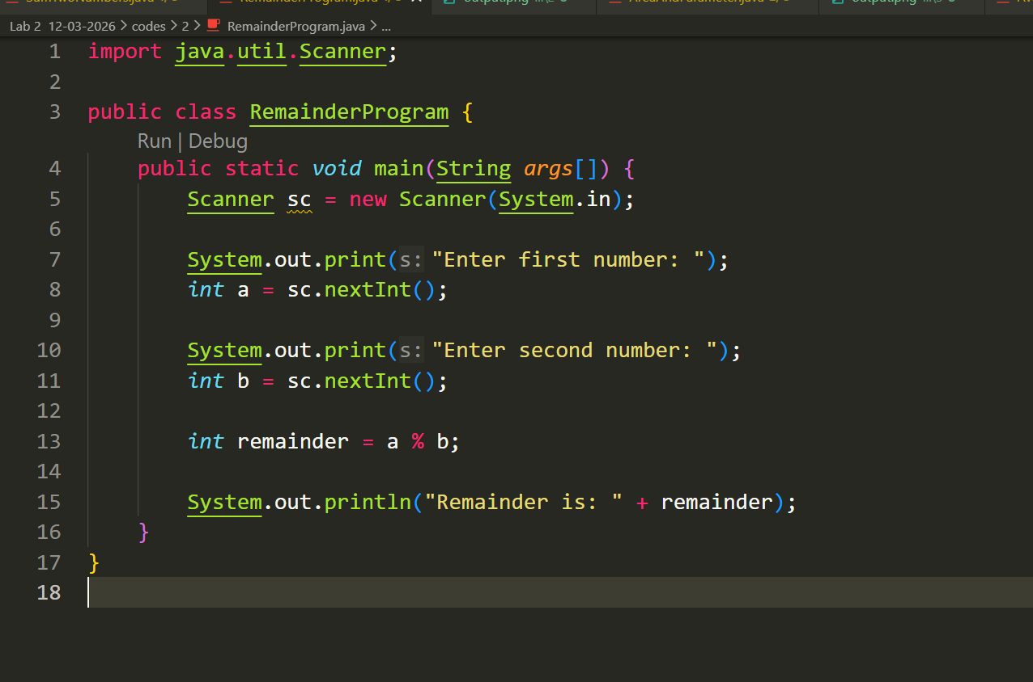

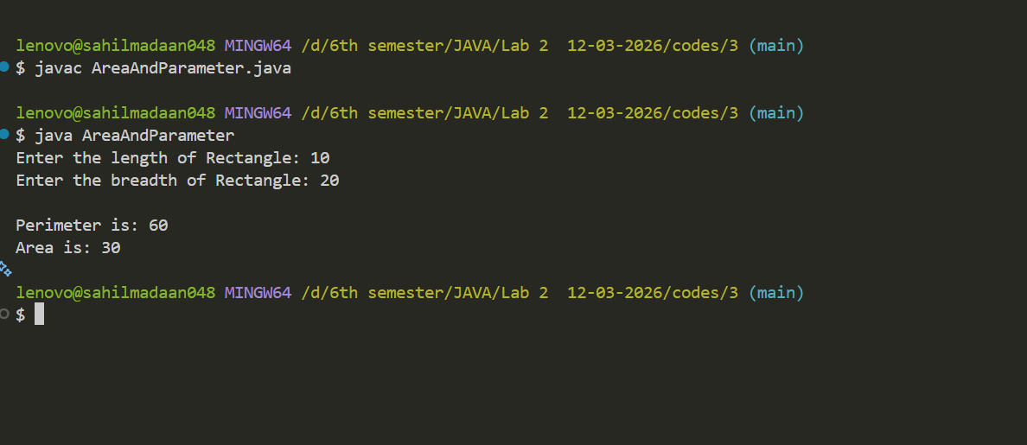

Lab 2
- Write a Java program to calculate the area and perimeter of a rectangle using arithmetic operators.

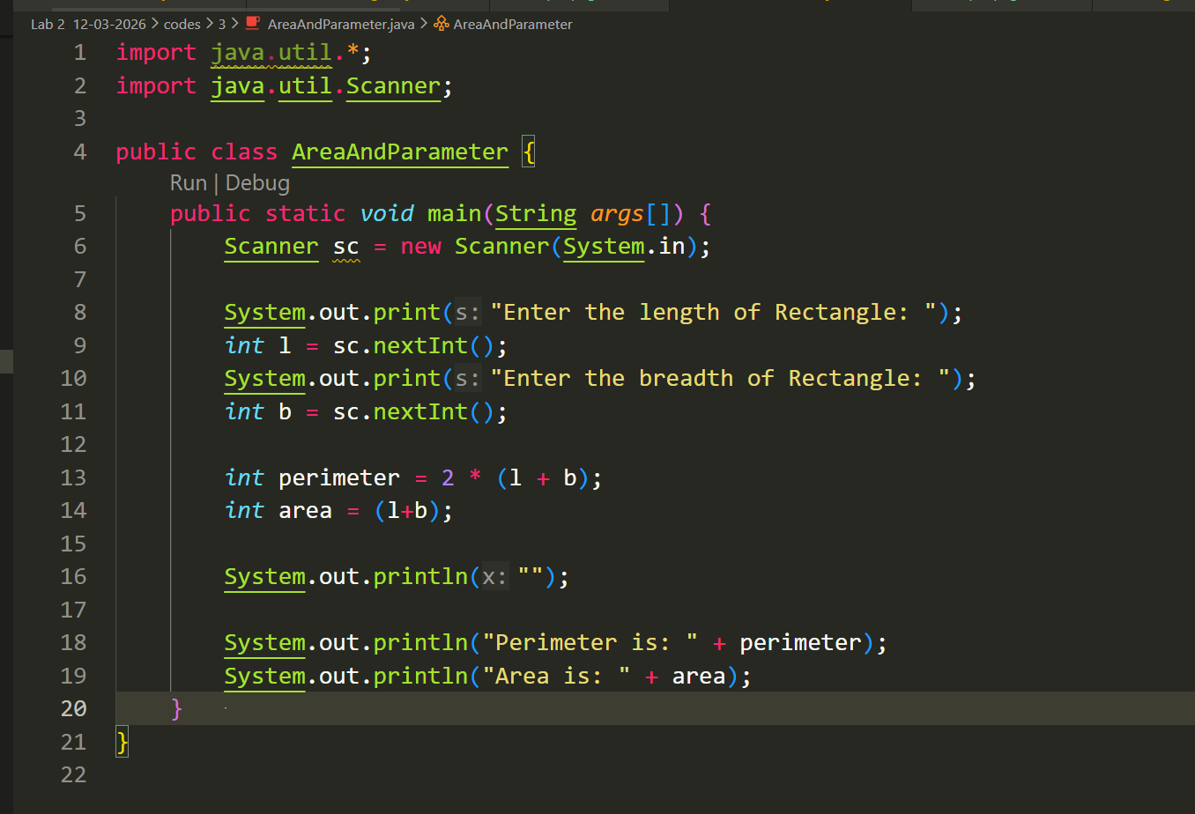

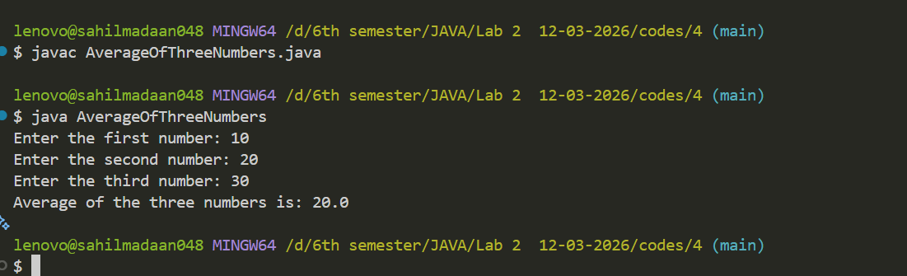

Lab 2
- Write a Java program to calculate the average of three numbers.
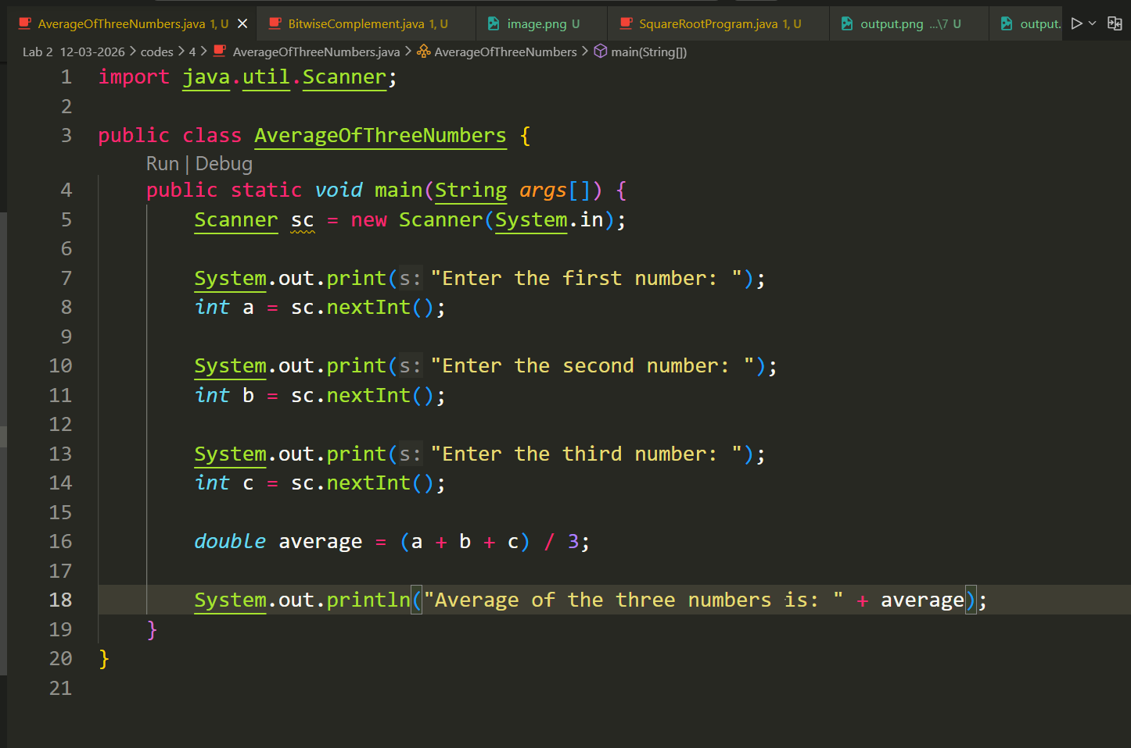

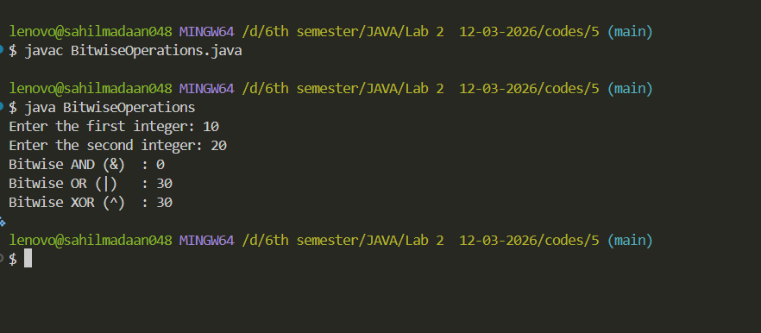

Lab 2
- Write a Java program to demonstrate the following bitwise operators on two numbers:
- AND (&)
- OR (|)
- XOR (^)

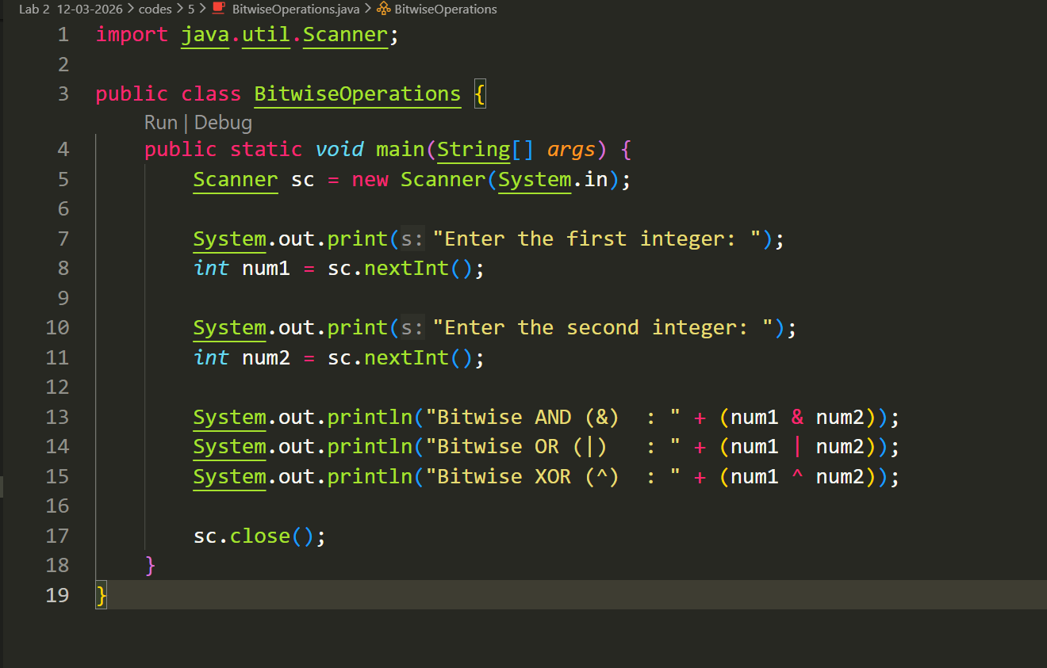

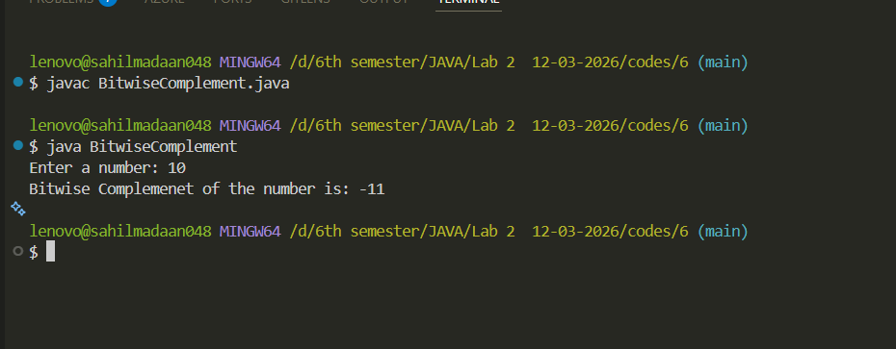

Lab 2
- Write a Java program to find the bitwise complement (~) of a number.
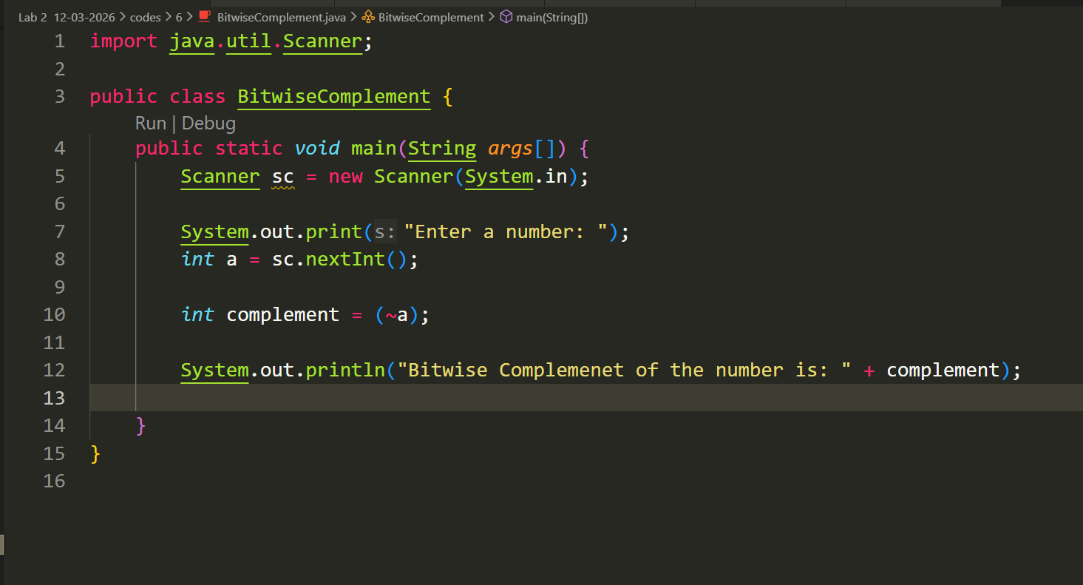

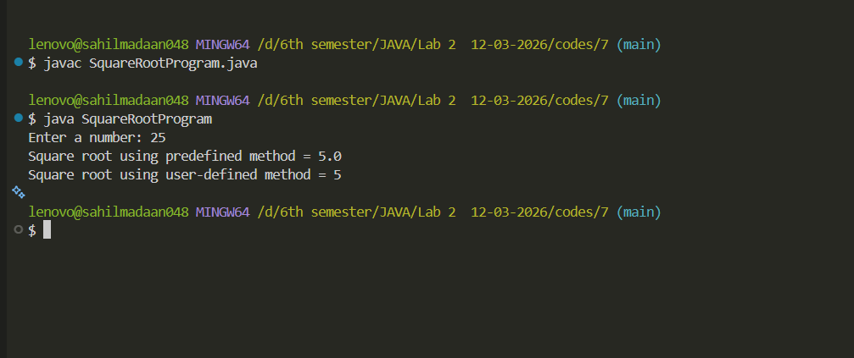

Lab 2
- WAP to find the square root of a number using predefined method and also using user-defined method of square_root (without predefined).

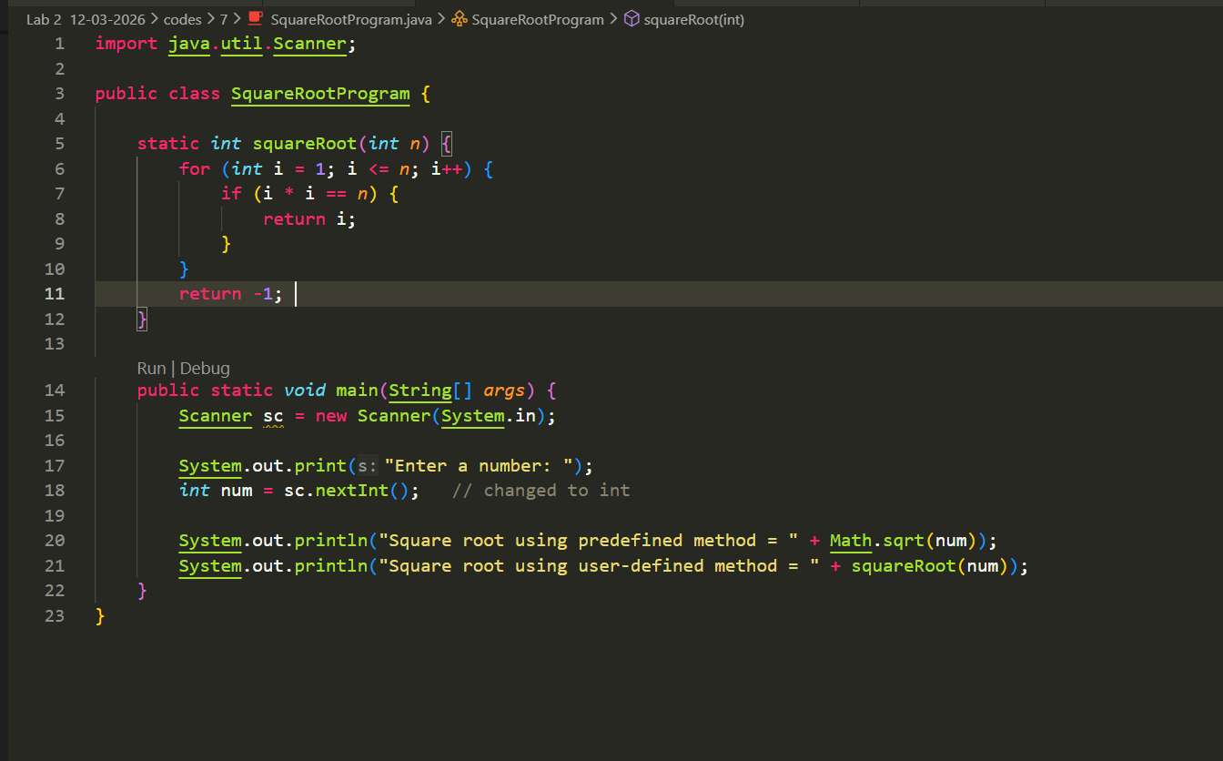

Lab 2
- Write a Java program that defines a method max taking two arguments to returns the largest of two numbers.
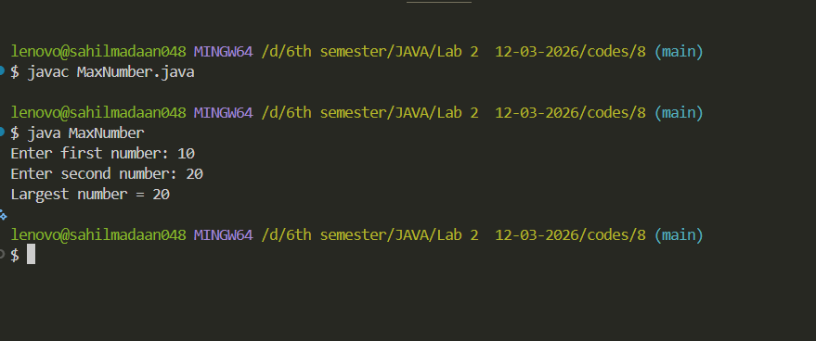

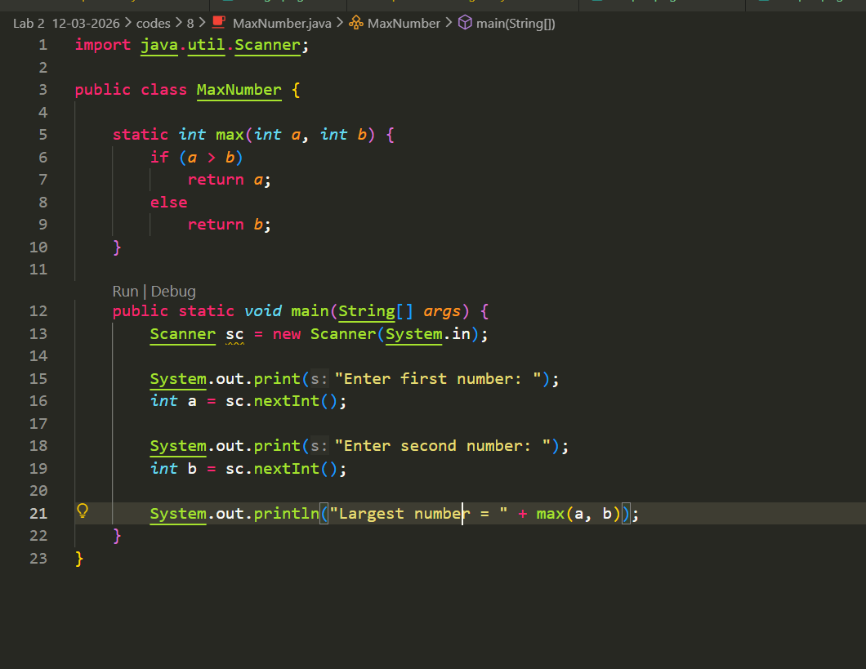

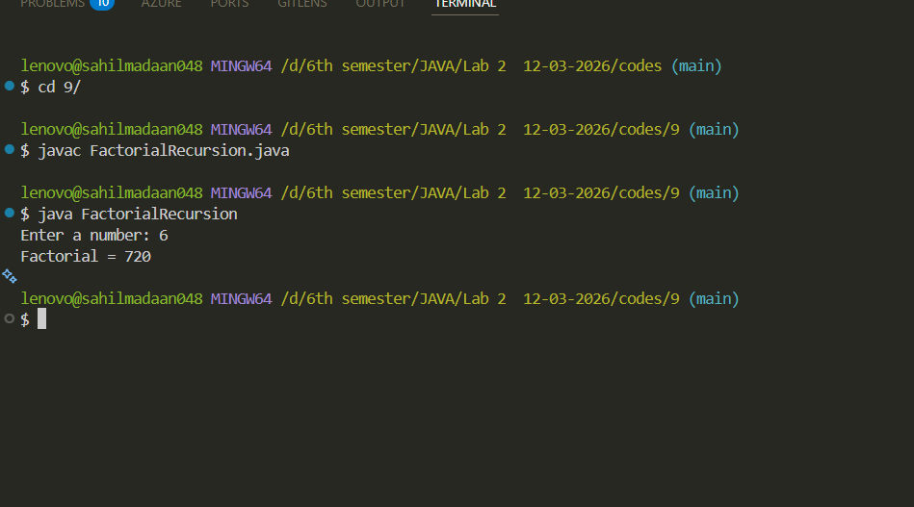

Lab 2
- WAP a program to find the factorial of a number using recursion (using methods). (Optional Program)

